Day-6:

Deployment Preparation and Staging Environment Setup

“Food Restaurant”

1. Staging environment deployed Link.

Vecel:

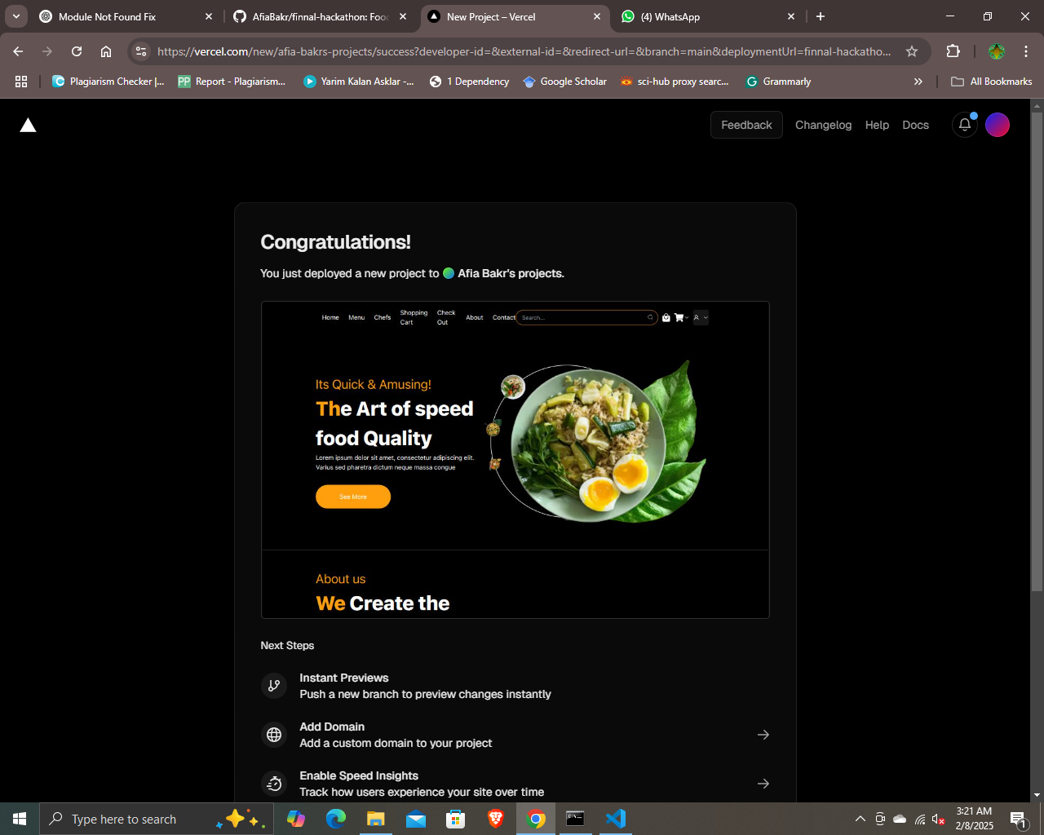

<https://finnal-hackathon.vercel.app>

1. A new GitHub repository:

Includes

* + *A documents folder containing all Day 1 to Day 6 documents.*
  + *Test case report in CSV format.*
  + *Performance testing results.*
  + *Organized project files*

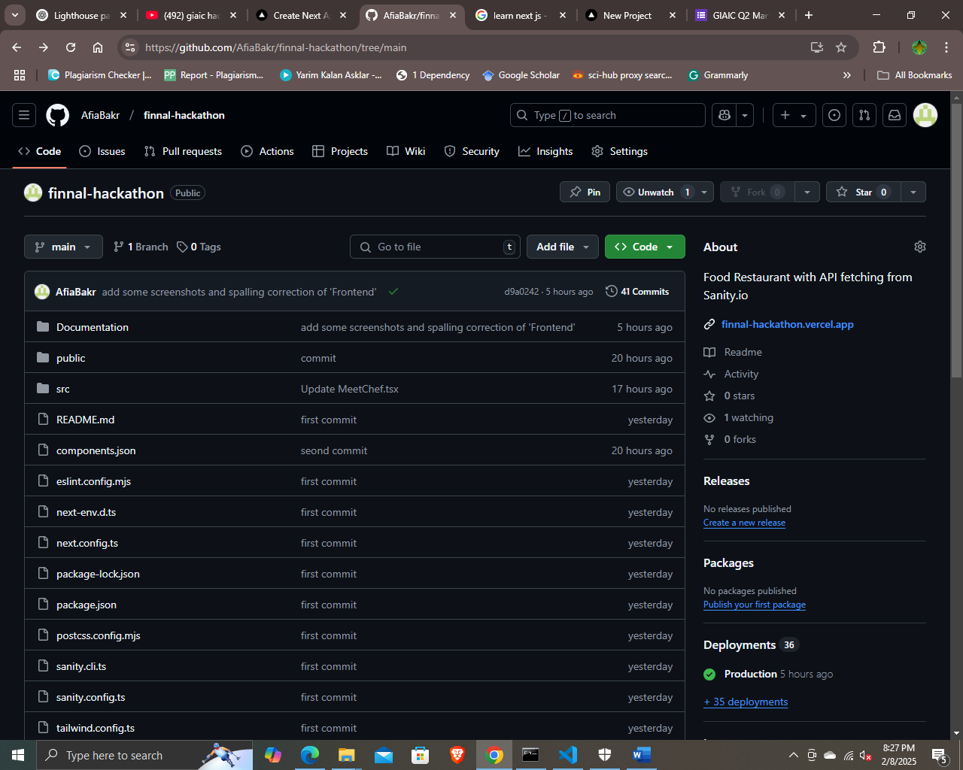

<https://github.com/AfiaBakr/finnal-hackathon.git>

1. Checklist for Day 6:

* Deployment Preparation: • ✔
* Staging Environment Testing: • ✔
* Documentation: • ✔
* Form Submission: • ✔
* Final Review: • ✔